60th Australian National
Diamond Jubilee
Square Dance Convention

24th-28th April 2019
Deloraine Community Complex, Alverston Drive, Deloraine, Tasmania
Further Details: Secretary, Kaye Chandler, P 0 Box 796, LAUNCESTON, TAS, 7250
or email: tassquare@bigpond.com.au

Celebrating 60 years of National Conventions:

Well what can we say, we’ll celebrate square dancing over the traditional 5 days however there will be 6 nights of dancing following our partnering with 3 of Australia’s major callers. This will commence with 150 years of calling, which is the celebration of 50 years for Kevin Kelly, Nev McLachlan and Steve Turner (subject to a separate charge). After this we will then commence with the celebration of 60 years by following the traditional program outline of conventions with a few special moments as we endeavor to celebrate those 60 years.

Committee changes:
From our original committee, regrettably, we have had a number of resignations for one reason or another; however we are still convinced that we are more than prepared and capable of producing another great Tasmanian Convention with:
Convenor Barry Chandler
Secretary Kaye Chandler
Treasurer/Registrar Katie Matthews
Assistant Treasurer Paul Ashton
Program Di Ashton
Publicity Marj Tuffnell
Venue Nelson Cooper
Committee Sandra Hazzlewood
Board Liaison Nev McLachlan

Venues:

As noted last year, the selection of the Deloraine Community Complex presents a new phase for square dancing within Tasmania and a new era for Australian National Conventions as this will be the first convention held in a regional town. This may seem somewhat a strange decision but I can assure all dancers that the town will surprise all delegates. Deloraine hosts a craft fair each year which hosts over 20,000 visitors over 4 days every November, so we are confident that with their community support this will be a convention not to be missed.
Deloraine Community Complex provides meeting, function and indoor sports and convention facilities. The facility was built in 1988 and funded in part by the Australian Government as part of the celebration of the bi-centenary of European settlement in Australia. Located on Alveston Drive, Deloraine, the venue can provide for events for around 500 people. A large commercial kitchen, stage, projection screen, audio equipment, and ample parking are available.

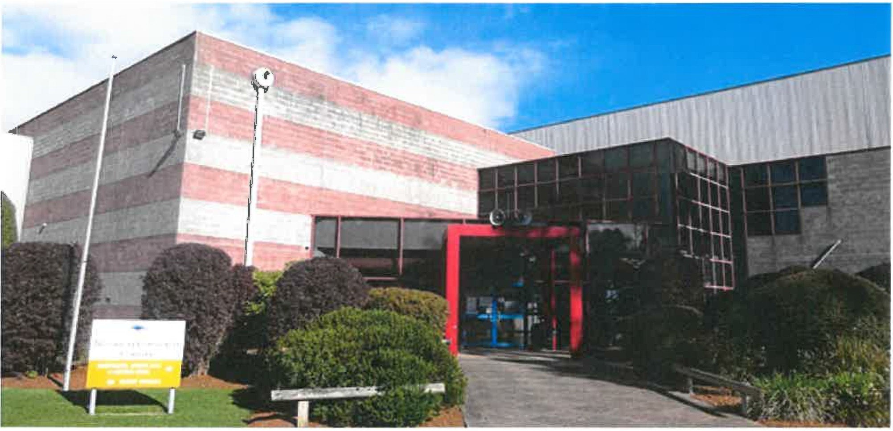
Community Complex Facilities:
- Indoor Sports with change rooms and associated facilities
- Function Spaces
- Basketball
- Netball
- Badminton
- School Sports Venue
- 3 Function Spaces

Auditorium Function Space Facilities:
  - 4 Levels
- Stage
- Kitchen
- Audio
- Projection Screen
- Air-Conditioning
- Function Space. Size: 15m x 15m
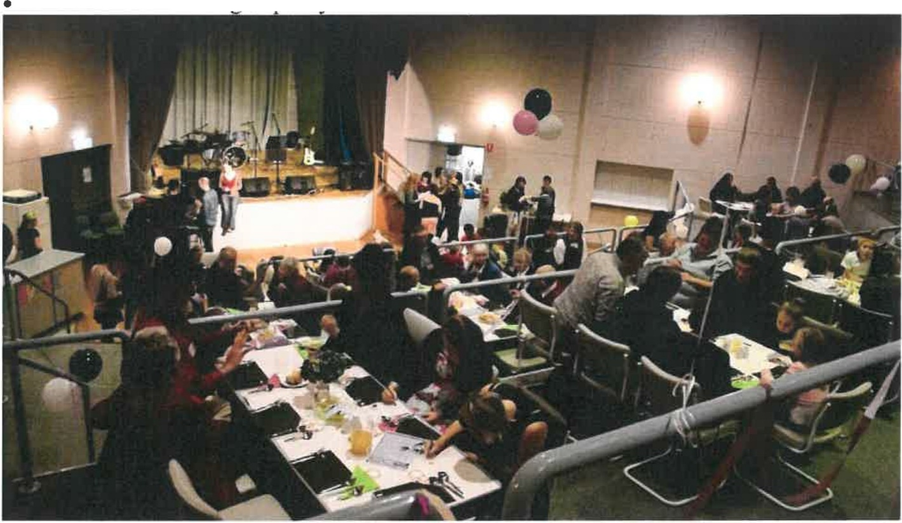
Seating Capacity: Theatre - 250, Dinner - 200

Meeting Room Function Space Facilities:
- Whiteboard
- Screen
- Sink
- Hot Water Um
- Air-Conditioning
- Function Space. Size: 1Om x 6m
- Seating Capacity: Theatre - 35, Dinner - 20

Stadium Function Space Facilities:
- Function Space. Size: 32m x 35m
- Seating Capacity: Theatre - 500, Dinner -400

- A second venue, being the local bowls club, is located close by and it is anticipated that a mini bus (or Tarago type vehicle) will operate between the venues during the day catering for dancers who alternate between the venues or for spectators who wish to view a number of forms of dancing.

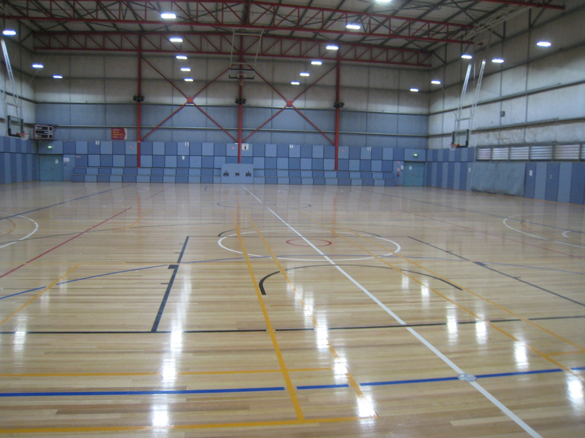

Timing:
The convention dates are Wednesday the 24th to Sunday the 28th April 2019. A Website has been set-up giving possible convention goers an insight into our theme and a wealth of information on the up and coming convention. As has previously been approved the program will be managed with the appropriate changes as follows:
Wednesday Night Trail In Dance
Thursday Night Opening Night
Friday Night Dress Sets
Saturday Night Closing
Sunday Night Dress up
Budget:
We have prepared and subsequently reviewed the budget (as attached), now based on 450 dancers with a view of reduction of the current cost of registration as used by the 58th National and the 59th Nationals as a way of encouraging more attendees, which seems assured from initial feedback being received.
Following a change in legislation there will be no credit card fee but as is the current practice a charge will be levied for refunds, bank refusals and a no refund policy (except under special circumstances after packages are forwarded out) will be applied.

Accommodation:

We are aware that a number of properties within the area only list themselves 12 months out so we have partnered with the Great Western Tiers Visitors Information Centre who will endeavor to support all local accommodation. Additional accommodation may be available in a number of local towns of Sheffield and Westbury or the nearby cities of Launceston or Devonport. Both of these cities are within an easy access similar to that experienced recently of Mooloolaba to Buderim and the venue of the 57th National Square Dance Convention.

Promotion:

We will be manning our display at the convention (59th National) and will continue to work on our Internet and Facebook site with the provision of all information.

Crèche:

Child minding will be provided for up to 7 years old and also for 8 years and over within the complex however we reserve the right not to provide this if there are insufficient registrations to cover the minimal staffing levels required.

Transport I Tours:

To assist with transport an arrangement will be established with Hertz for discounted hire. Information on tours can again be sourced from Great Western Tiers Visitors Information Centre via their website (greatwesterntiers.net.au) or for wider options check out www.discovertasmania.com.au
The TT-Line has set-up a web-site which will give delegates a discount and reminder prompts to allow bookings once these become available.

Program:

A draft program has been provided (as attached) for all meetings and dance times. We will view any amendments from board members and national committees, along with observing the success of 59th National Conventions and considering the dancers indication prior to finalising the program.

We hope that you will all join us to ensure that we dress-up, with glitz & glamour to celebrate this 60th Australian National Square Dance Convention

Barry Chandler, Convenor

